**SUPERSTORE SALES PERFORMANCE – CAPSTONE PROJECT**

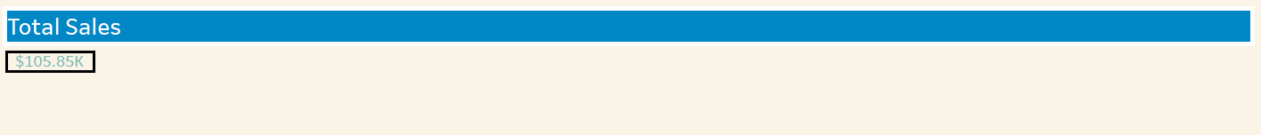

1. **Total Sales**

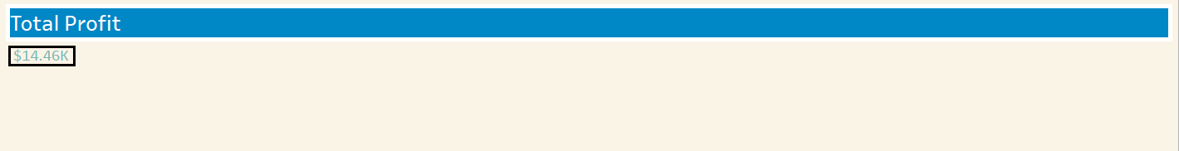

1. **Total Profit**

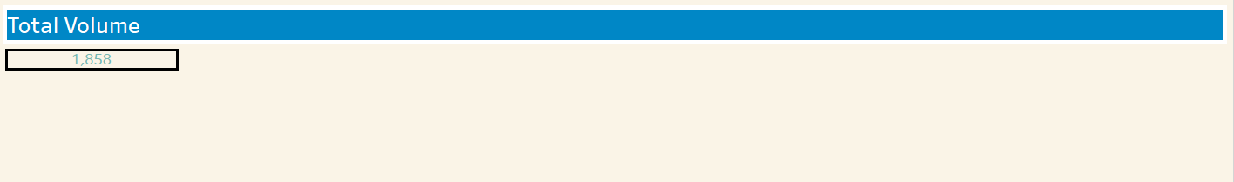

1. **Total Volume**

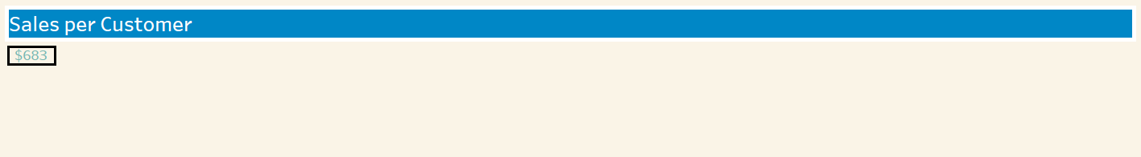

1. **Total Sales per Customer**

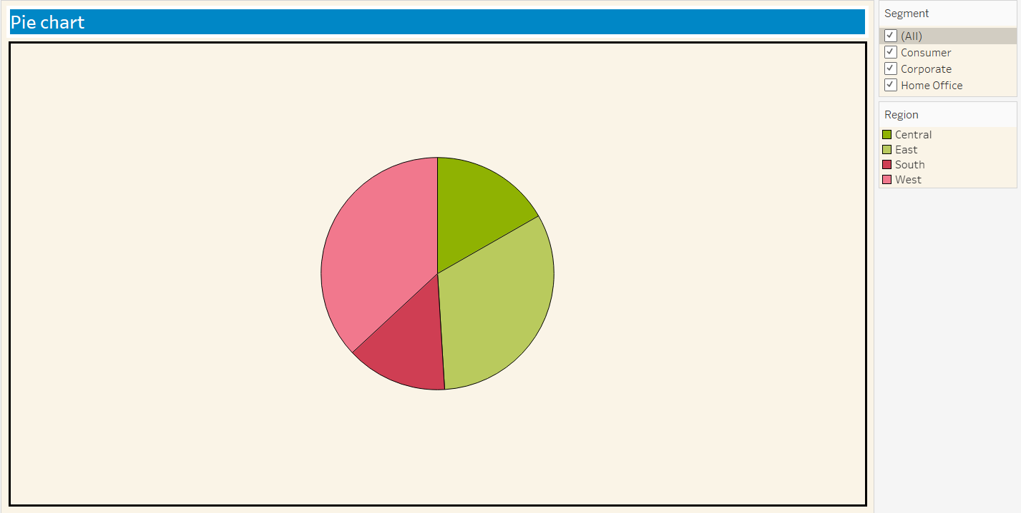

1. **Pie Chart**

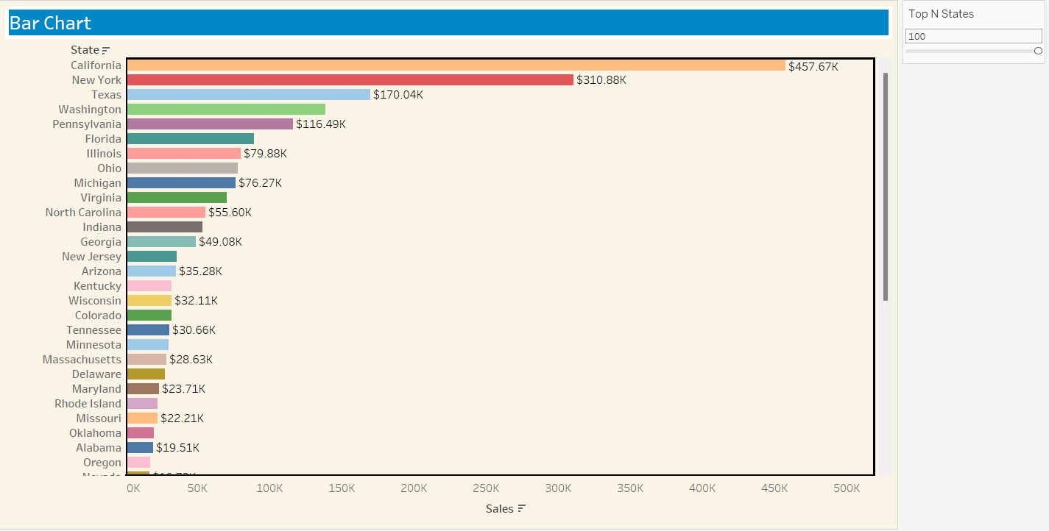

1. **Bar Chart**

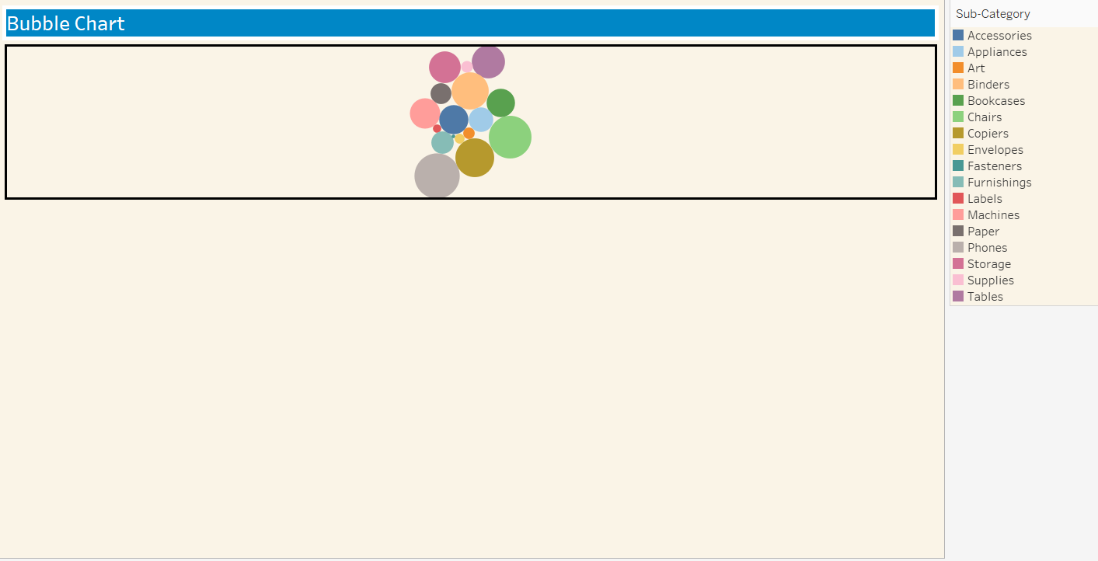

1. **Bubble Chart**

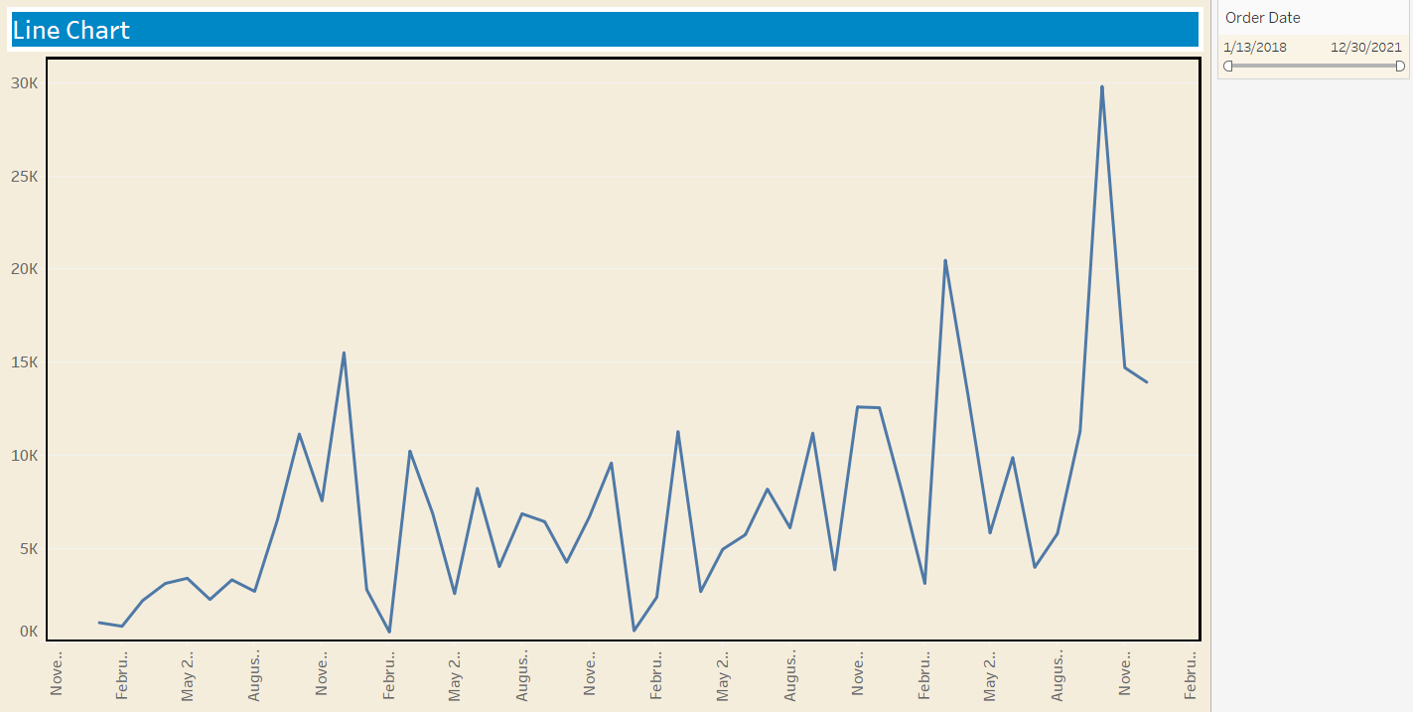

1. **Line Graph**

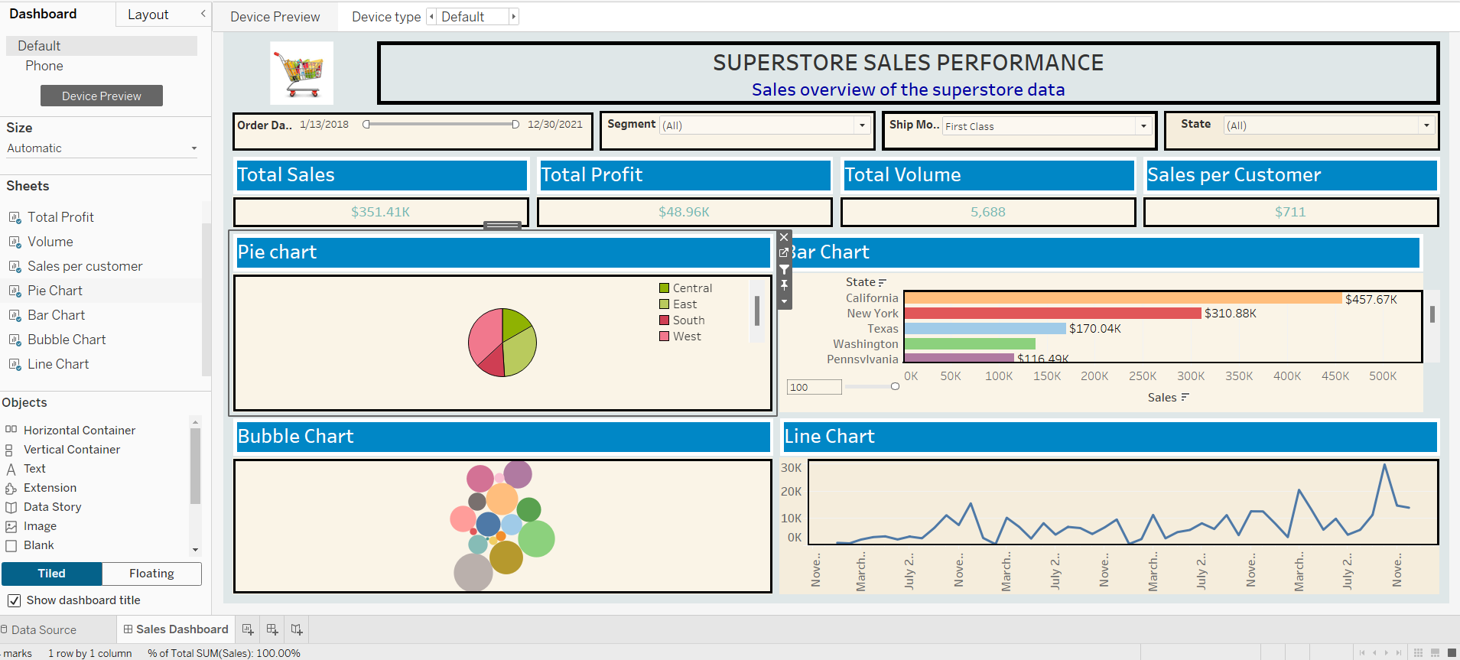

1. **Dashboard view of the Superstore Sales Performance**